**INSTRUCTIONS**

1. This assignment is divided into five challenges – all activities in these challenges must be completed.
2. This assignment requires both Power BI desktop and Power BI service (<http://app.powerbi.com>)
3. You must have Power BI Pro license assigned to your (@cognizant.com) account to complete this assignment. If you don’t have Pro license, write to Academy point of contact.
4. You have two options to complete this assignment
   1. Use Power BI Desktop in Power BI On Demand Lab in Cognizant LEARN (or)
   2. Use Power BI Desktop (latest version), if installed, in your local computer

Option (4.a)

1. Click [here](https://cognizantlearning.sumtotal.host/Core/pillarRedirect?relyingParty=LM&url=https:%2F%2FCOGNIZANTLEARNING.sumtotal.host%2Flearning%2Fcore%2Factivitydetails%2FViewActivityDetails%3FUserMode%3D0%26ActivityId%3D1228614%26ClassUnderStruct%3DFalse%26CallerUrl%3D%2Flearning%2Flearner%2FHome%2FGoToPortal%3Fkey%3D0%26SearchCallerURL%3Dhttps%253A%252F%252FCOGNIZANTLEARNING.sumtotal.host%252Fcore%252FsearchRedirect%253FViewType%253DList%2526SearchText%253Dpower%25252520bi%25252520on%25252520demand%25252520lab%2526startRow%253D0%26SearchCallerID%3D2) to register and start the Power BI On Demand Lab
2. Open Power BI Desktop shortcut on the desktop
3. Data files referred in this assignment is available in Data.zip on the desktop
4. Extract the Data.zip file to a folder in the virtual machine to proceed
5. The on-demand lab will be available for 4 hours. You will lose your work after 4 hours. So, complete all the activities in this assignment within 4 hours.

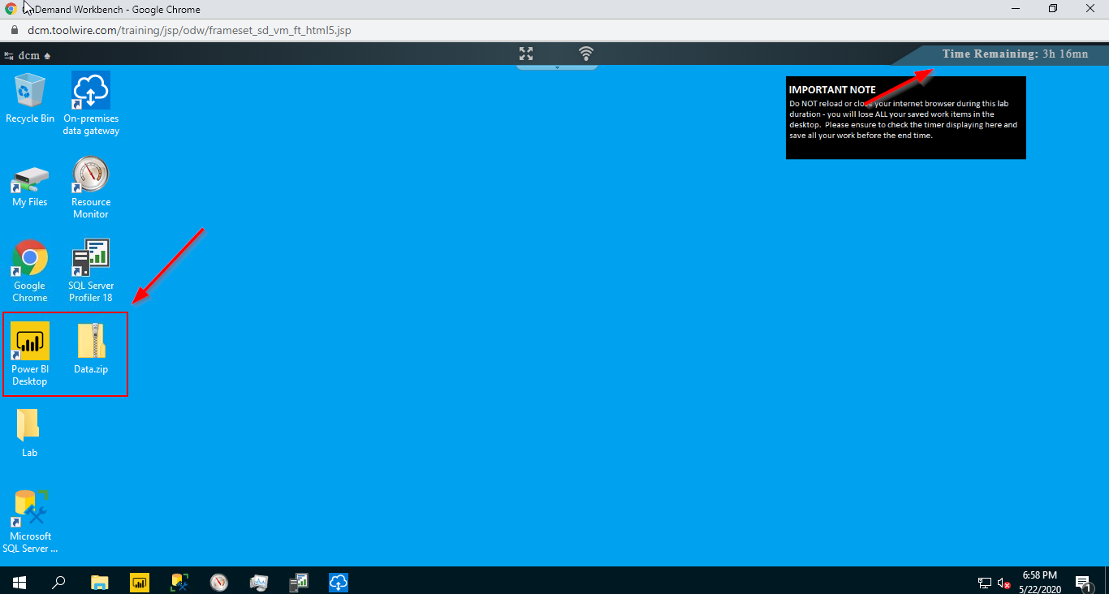

Option (4.b)

1. If you have Power BI desktop installed in your local computer, download the Data.zip from this [link](https://cognizantonline.sharepoint.com/:f:/s/AIASolutionTEAMS/End8JZHr2eFLiwpdJR0qk3cB0PCXenLZkzPZ3c4yBDPj7A?e=FZpLcf) and complete this assignment.
2. As part of the below five challenges you will create a report in Power BI desktop named “Details.pbix” and also create an app with the name “<Your Name> - VanArsdel App in Power BI service.
3. Once the report file and app is created, register for the assignment and submit the details 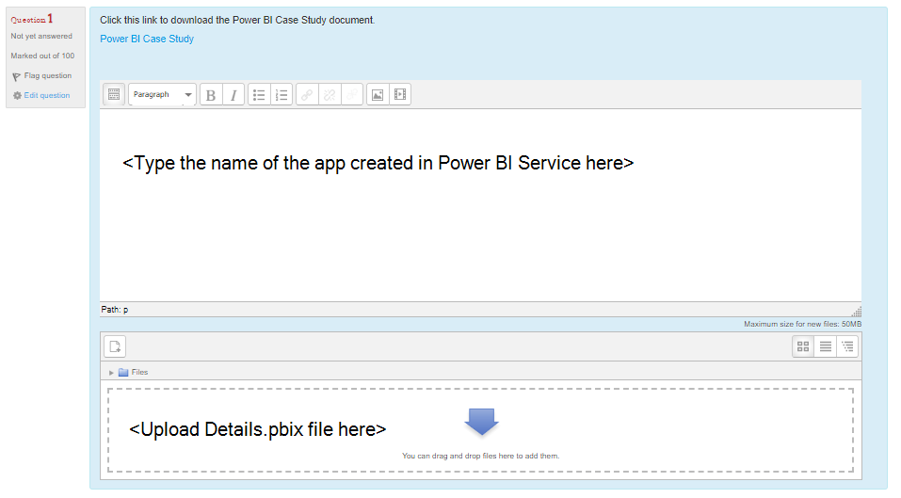

**Background**

VanArsdel has many competitors, but is the market leader in its industry. The CMO wants to increase market share and discover growth opportunities. However, for unknown reasons, VanArsdel's market share has started to decline. You are asked to help the CMO to understand the reasons for decline in sales.

You are given sales data of VanArsdel and other competitors. The sales data includes 7 years of transaction data by day, product and zip code for each manufacturer. CMO is interested only on the last 3 years data available in the sales data.

**Data Set Structure**

1. USA sales data is in a csv file located in /Data/USSales folder
2. Sales of all other countries is in /Data/InternationalSales folder. Each country’s sales data is in a csv file in this folder.
3. Product, Geography and Manufacturer information is in an excel file in /Data/USSales/bi_dimensions.xlsx.

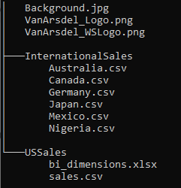

**Challenge #1 – Access Data**

1. Name of the Power BI file must be “Details.pbix”
2. Create International Sales, US Sales, Product, Geography, Manufacturer queries
3. Group the queries as fact and dimension
4. Create query parameters and use them in the queries appropriately

**Challenge #2 – Shape**

1. In all queries, rename column names, change data types based on column profile
2. In Product query, fill empty or null values and split columns having too much information
3. In Geography query, remove informational rows
4. In Manufacturer query, convert rows to columns
5. Create a new Sales query that appends International Sales and US Sales queries

**Challenge #3 – Model**

1. Your model should have only fields and/or tables needed for visualization
2. Data type, data category, summarization should set properly
3. Use measures and columns as required
4. Create relationship and set cross-filter direction as appropriate

**Challenge #4 - Visualize**

1. You can create one or more pages as required
2. Use the Varsdel_Logo.PNG file as logo in all pages
3. All pages should use “background.jpg” as the background image.
4. Display the total revenue of all manufacturers
5. Display the total revenue of VanArsdel
6. Display the top 5 competitors of VanArsel by revenue
7. Display total sales of manufactures by country, state and city
8. Display competitors performance across product categories and segments
9. Analyze what drives the sales amount of each competitor
10. Display the total year-to-date sales of the manufactures across year and month name
11. You need to convey Powerpoint-like presentation to convey a story by manufacturers, product categories and segments
12. The above visuals can be filtered by one or more manufacturers by report consumer

**Challenge #5 – Share**

1. Create a new workspace “<Your Name> - VanArsdel” in Power BI service.
2. Publish the report from Power BI desktop to this workspace
3. Set two featured questions for the dataset published in this workspace. These questions should be visible in Q&A question box.
4. Create three dashboards in this workspace
   1. “Overview” – this should have visuals that displays key information of VarArsdel
   2. “Opportunities” – this should have visuals that displays opportunities that VanArsdel shouldn’t miss
   3. “Threats” – this should have visuals that displays risks VanArsdel should be aware of
5. CMO will access this report through Power BI mobile app as well as web browser. In mobile view, the report should display only total revenue of VanArsdel and top 5 competitors of VanArsdel visuals
6. Publish an app from this workspace.
   1. Name the app as “<Your Name> - VanArsdel App”
   2. VanArsdel_WSLogo.png is set as app logo
   3. Description of the app is set to “This application is a single place to access all official data of VanArsdel and its competitors sales”
   4. Its navigation must have like the one below

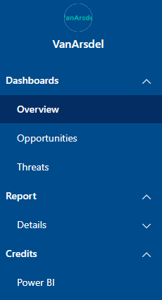

* 1. Overview, Opportunities and Threats are the dasboards, Details is the report and Power BI is a link to <https://en.wikipedia.org/wiki/Microsoft_Power_BI>
  2. This app should be accessible only to everyone and they must not be able to access the underlying dataset and share the app to others.